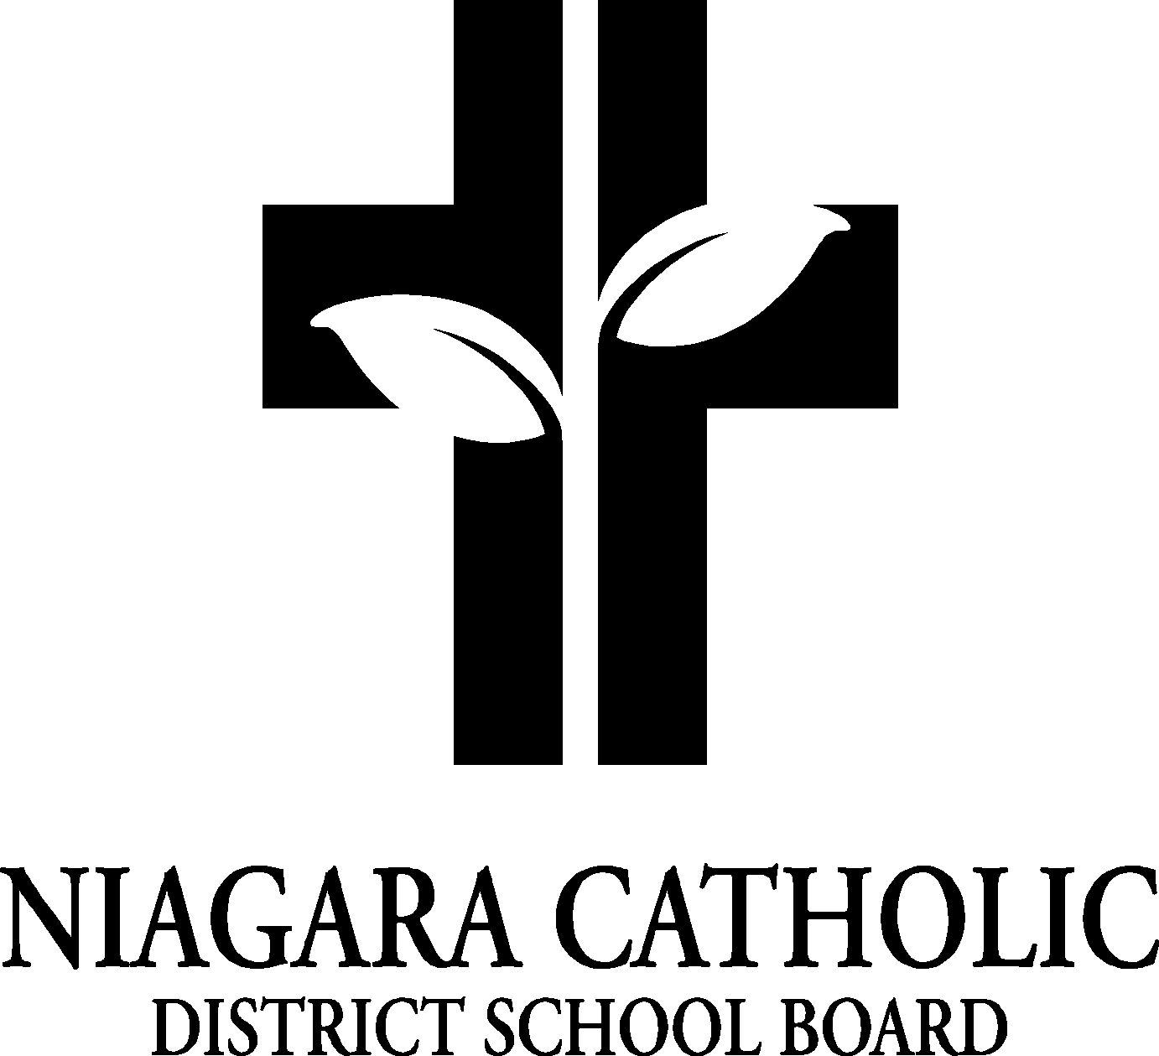

**A G E N D A**

**OUR LADY OF FATIMA CATHOLIC SCHOOL COUNCIL MEETING**

Tuesday September 21, 2021- 6:00 pm

Virtual Meeting via Google Meet

**A. ROUTINE MATTERS**

1. Opening Prayer
2. Roll Call- please email ([rosetta.araujo@ncdsb.com](mailto:rosetta.araujo@ncdsb.com)) your name, address, phone number and confirm that the email you are using is the one you would like me to keep on file
3. Approval of the Agenda
4. Election of Chair and/or Co-Chairs
5. Election of the Ontario Association for Parents in Catholic Education (OAPCE) Representative
6. Approval of Minutes (N/A)- first meeting of the year

**B. PRESENTATIONS- 2021 By-laws (Constitution) and CSC Policy (*copies will be emailed to all members of CSC following this zoom meeting)**

**C. PRINCIPAL’S REPORT**

1. Niagara Catholic Parent Involvement Committee (NCPIC) Report-N/A
2. Special Education Advisory Committee (SEAC) Report- none to report
3. Catholic School Council Financial Report- review current balance
4. Potential Goals for this year- New supplies in Kindergarten, new technology in the classroom, new jerseys, music equipment, new Math materials to support new curriculum, Kinder cameras, yearbook camera

**D. OAPCE REPORT- N/A**

**E. STAFF REPORT- T. Kovacs and D. Littler**

**F. AGENDA ITEMS-DISCUSSION FOR FUTURE MEETINGS**

1) Discuss goals for this year

2) Fundraising initiatives for this year (DFS Canada?)

3) Set all future meeting dates

4) open discussion- Questions from the members

**G. NEXT MEETING- TBD**

**H. ADJOURNMENT**

**I. CLOSING PRAYER**